Euler brick

Def

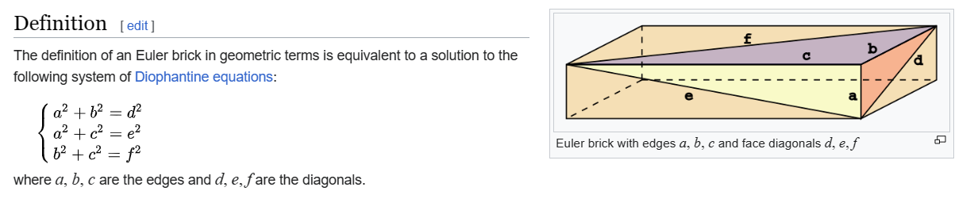

Property

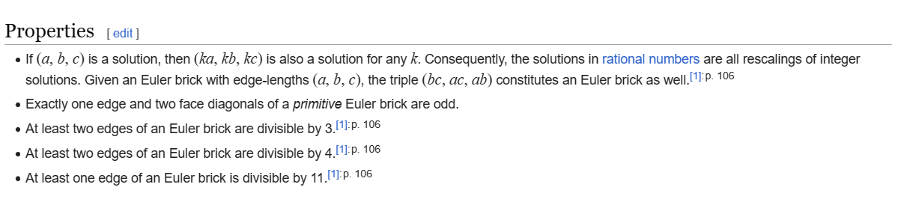

Proof

$$\left(a,b,c\right)$$

=> $${\left(a\right)}^{2}+{\left(b\right)}^{2}={\left(d\right)}^{2}$$, $${\left(a\right)}^{2}+{\left(c\right)}^{2}={\left(e\right)}^{2}$$, $${\left(b\right)}^{2}+{\left(c\right)}^{2}={\left(f\right)}^{2}$$

which makes

$$\left(ka,kb,kc\right)$$

=> $${\left(ka\right)}^{2}+{\left(kb\right)}^{2}={\left(kd\right)}^{2}$$, $${\left(ka\right)}^{2}+{\left(kc\right)}^{2}={\left(ke\right)}^{2}$$, $${\left(kb\right)}^{2}+{\left(kc\right)}^{2}={\left(kf\right)}^{2}$$

Ref

[Euler brick - Wikipedia](https://en.wikipedia.org/wiki/Euler_brick)